CN Lab 5
K225195 Laiba Fatima
Class Activity
Nu mail
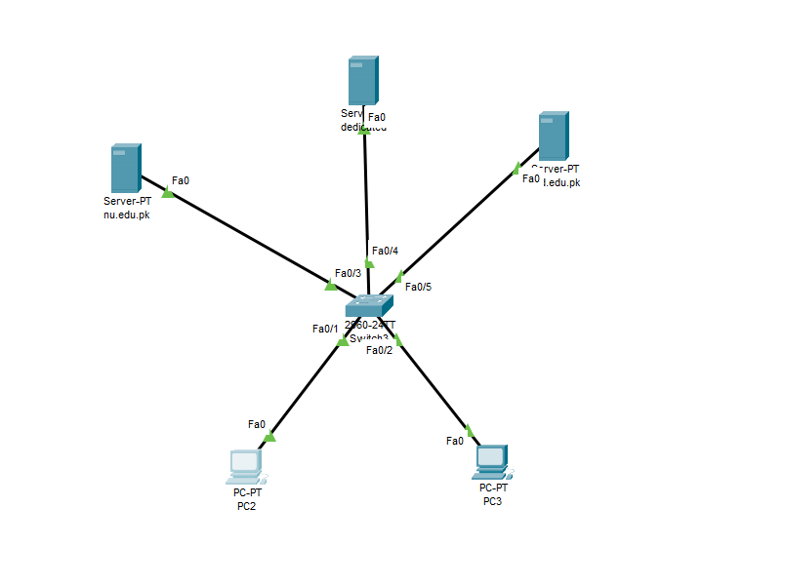
Crossover communication
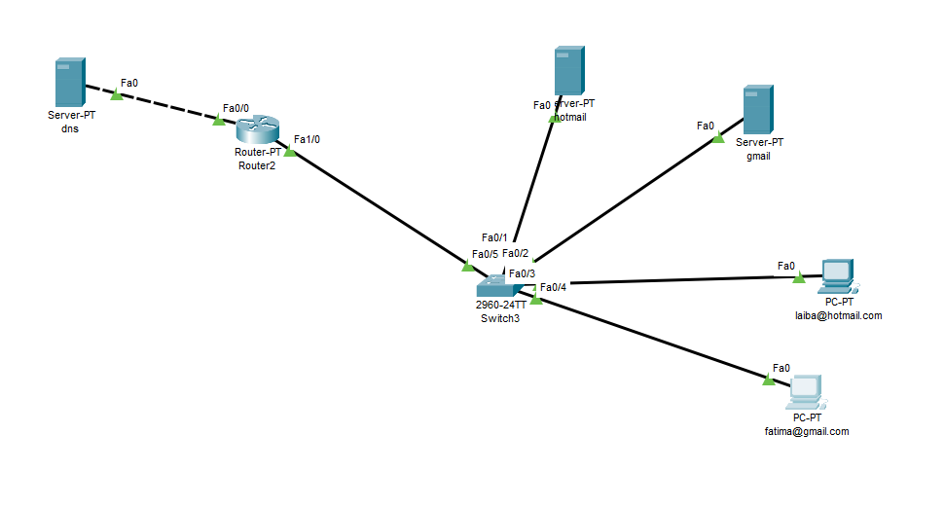
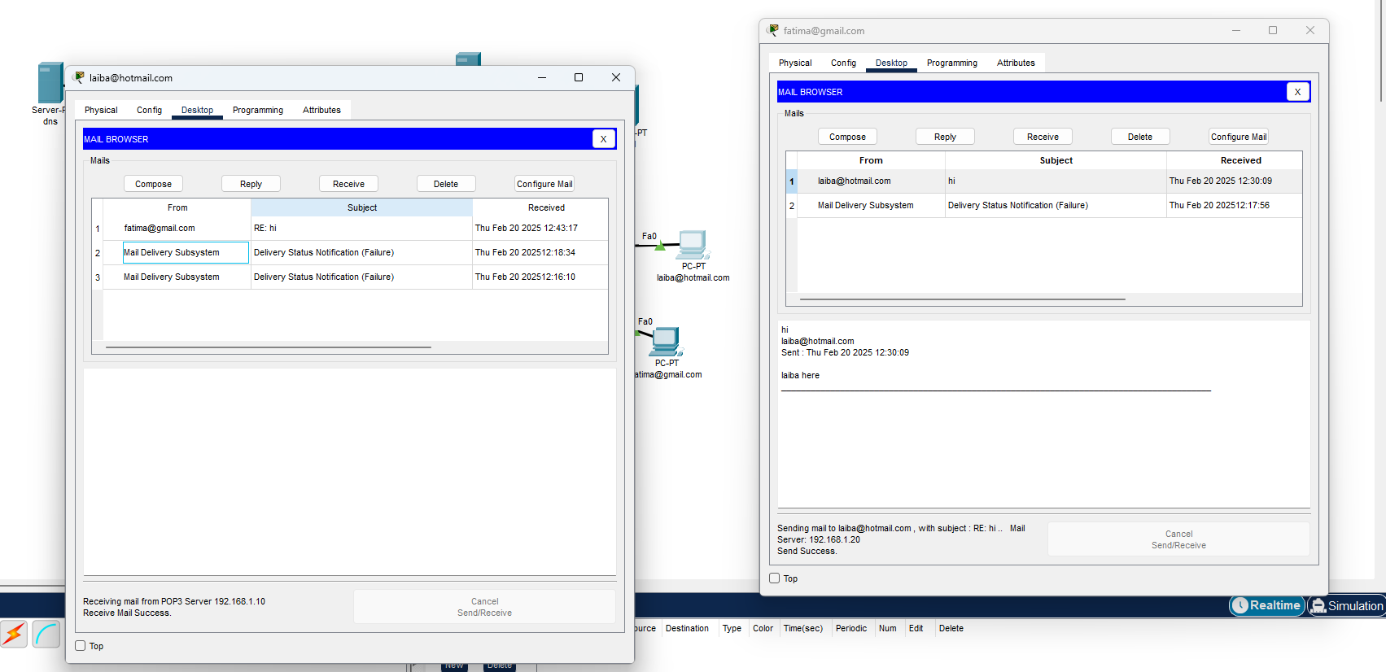

FTP
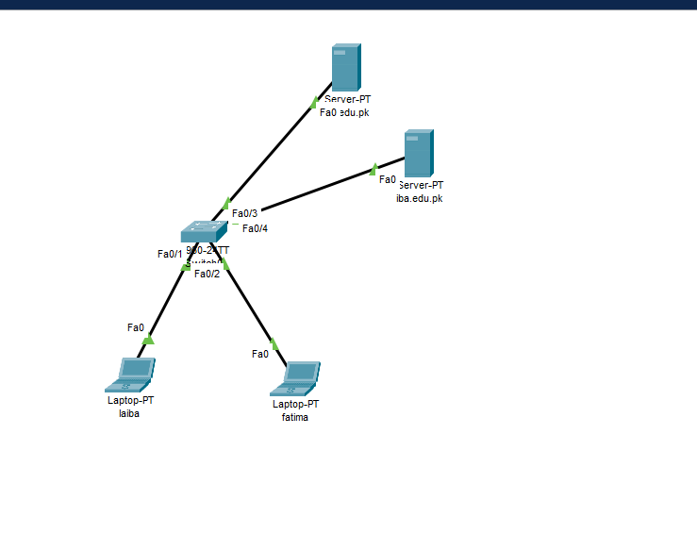
Lab Tasks

1.
2.
3.

